**MEMORANDUM OF UNDERSTANDING**

**between**

**_________【廠商名稱】______________**

**___________________________________**

**and**

**(Dept./ Inst.) , Hungkuang University**

**Taichung City, Taiwan**

Recognizing the mutual interest and benefits in strengthening industrial-academic cooperation within a framework of friendship and in pursuance of their desire to cooperate in defined areas, Hungkuang University and （hereinafter referred to as the “Parties”）have reached the following understanding:

1. Both Parties agree to encourage and promote cooperation in the fields of technological developments, pertaining to industrial technology, technology strategy, marketing strategy, R&D management, and technical information and training. (合作範圍)

2. This MOU is subject to revision, renewal or cancellation by mutual consent, and becomes effective upon completion of the signatures, valid for a period of years from the date of signing indicated below. It may be extended for a further period by agreement between both Parties. (合作期限)

3. Both Parties agree to pursue the above by:(可依實際情形自行增修/刪減以下合作項目)

(1) Carrying out joint projects identified in areas of mutual interests;

(2) Coordination in joint or collaborative research projects;

(3) Exchange of information and expertise in the research and development of industrial technology;

(4) Coordination in planning on training courses, and providing practical experience professionals to serve as teachers in relevant courses;

(5) Exploring opportunities for cooperation in any other areas of mutual interests;

(6) Other activities as may be mutually agreed by the two parties to this Agreement.

Details of the implementation of any particular collaborative agreement shall be negotiated between the two Parties as such specific cases arise. (執行細節雙方協商)

4. The form and cost for individual activities of cooperation under this MOU shall be agreed upon by both Parties. (活動執行的形式和費用雙方協定)

5. When agreed, the activities concerned shall be implemented in accordance with the prevailing laws and regulations in the relevant place in which the activity is being undertaken. (需在現行法律法規下執行)

6. This MOU may be amended and supplemented as decided and agreed by both Parties. (內容修訂或新增須雙方決定與同意)

7. Either Party may terminate this MOU by giving the other Party at least three months’ notice in writing. (終止需前三個月書面告知)

Hungkuang University Center (廠商名稱)

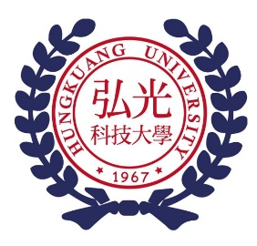

廠商Logo

|  |  |  |  |
| --- | --- | --- | --- |
| Representative： | __________________ | Representative： | __________________ |
| Title： | Director | Title： | __________________ |
| Dated: | (yyyy)/(mm)/(dd) | Dated: | (yyyy)/(mm)/(dd) |