**MEMORANDUM OF UNDERSTANDING**

**between**

**【Name of the (College/ Dept./ Inst. ) of The University】**

**and**

**(Dept./ Inst.), Hungkuang University**

**Taichung City, Taiwan**

This memorandum records the intention of name of the (College/ Dept./ Inst.) of the university and Hungkuang University to strengthen ties between the two universities, which might lead in the future to the establishment of one or more partnership agreements for exchange purposes or academic cooperation.

1. This Memorandum of Understanding (MOU) will come into effect on the day on which signed by both Universities. It will continue for a period of , thereafter this MOU may be extended for a further period by agreement between both Universities. (合作期限)

2. The signing of this MOU is made as a gesture of goodwill between the two universities, which may see the development of links in the areas of: (可依實際情形自行增修/刪減以下合作項目)

3. Both Universities agree to pursue the above by:

(1) Exchange of students for a given period through a recognized exchange program

(2) Exchange of faculty members of the universities

(3) Exchange of documentation and research material

(4) Staff development projects

(5) Coordination in joint or collaborative research projects

(6) Cooperation in efforts to commercialize technologies developed at the two universities or their partners in ways that are mutually beneficial

(7) Other activities as may be mutually agreed by the two universities to this MOU.

Details of the implementation of any particular collaborative agreement shall be negotiated between the two Universities as such specific cases arise. (執行細節雙方協商)

4. The form and cost for individual activities of cooperation under this MOU shall be agreed upon by both Universities. (活動執行的形式和費用雙方協定)

5. When agreed, the activities concerned shall be implemented in accordance with the prevailing laws and regulations in the relevant place in which the activity is being undertaken. (需在現行法律法規下執行)

6. This MOU may be amended and supplemented as decided and agreed by both Universities. (內容修訂或新增須雙方決定與同意)

7. Either University may terminate this MOU by giving the other University at least three months’ notice in writing. (終止需前三個月書面告知)

Hungkuang University (學校名稱)

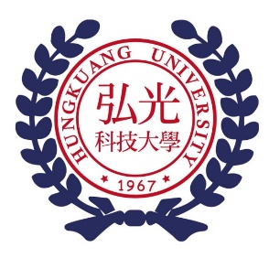

學校Logo

|  |  |  |  |
| --- | --- | --- | --- |
| Representative： | Hung-Yee Shu | Representative： | __________________ |
| Title： | President | Title： | __________________ |
| Dated: | (yyyy)/(mm)/(dd) | Dated: | (yyyy)/(mm)/(dd) |